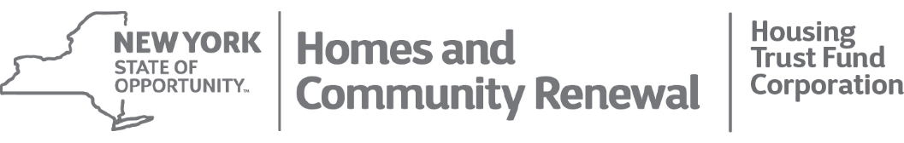
Andrew m. cuomo  Governor | RUTHANNE VISNAUSKAS  Commissioner/CEO

Build a career while building a better community. Rewarding careers in Public Service start here!

SENIOR COUNSEL

New York State Homes and Community Renewal (HCR) fosters the creation and preservation of high quality affordable housing for New Yorkers, while working strategically to revitalize neighborhoods and communities throughout the Empire State. Working under the leadership of Governor Andrew M. Cuomo and Commissioner RuthAnne Visnauskas, HCR is a vibrant, innovative Agency that integrates and leverages New York State’s housing and housing finance resources. We have offices in New York City, Albany, Buffalo and Syracuse, and employ a diverse workforce of professionals who are hard-working and committed to serving low- and moderate-income families. Our mission is far reaching, encompassing single and multi-family housing finance, home improvement, rent control, housing subsidies, and community development. We partner regularly with a variety of public and private stakeholders.

Achieving this mission requires a wide range of skills and backgrounds in public policy, administration, real estate, architecture, finance, law and many other areas of expertise. We seek to provide a workplace environment that is productive, flexible, accountable, ethical and caring. Our employees are empowered to make a difference where they live and work. We offer competitive pay and a comprehensive benefits package, including paid leave, health, dental, vision, and retirement and family-friendly policies.

FAIR AND EQUITABLE HOUSING OFFICE (FEHO) MISSION:
Our mission is to ensure New Yorkers have an equal opportunity to live in housing regardless of race, color, familial status, religion, sex, disabilities, national origin, marital status, age, and sexual orientation. The office is committed to removing barriers to housing at the state level and to affirmatively further fair housing. FEHO looks at how HCR’s public investments affect the larger housing market and works to engage our partners to ensure affordable housing is available in all areas of the State. FEHO oversees Section 3 compliance of grantees/subgrantees to ensure that economic opportunities generated by U.S. Department of Housing and Urban Development (HUD) financial assistance are, to the greatest extent feasible, directed to low- and very low- income persons.
RESPONSIBILITIES:
- Research legal issues and best practices, and draft legal and policy documents for the Director, HCRs Executive Team, Board Members and Chamber on various fair and equitable housing issues and laws;
- Develop internal policies, procedures and best practices to ensure HCR’s programs are satisfying fair housing requirements;
- Review Affirmative Fair Housing Marketing Plans and perform self-monitoring investigations to ensure developers are complying with fair housing laws;
- Coordinate with the Office of Legal Affairs and program staff on resolving fair housing complaints and issues;
- Conduct or arrange technical assistance on the Fair Housing Act’s duty to affirmatively further fair housing;
- Create educational materials and provide trainings to improve understanding of fair housing laws for both an internal and external audience;
- Ensure HCR’s compliance with all federal and state fair housing and civil rights laws;
- Attend and report on select statewide and national conferences on fair housing policy;
- Undertake special projects and assignments as assigned by Director and HCRs Executive Team.

QUALIFICATIONS:
- Law degree preferred, and 1 to 4 years in law practice;
- A housing and/or civil rights background is helpful;
- Ability to establish effective working relationships with staff, outside attorneys and constituents
- Ability to work under pressure on a wide variety of projects in a given day
- Excellent oral communication and presentation skills
- Excellent analytical and legal writing skills

This job description is not intended to be all inclusive, and the employee will also perform other reasonably related business duties as assigned.
WHAT WE OFFER:
- Extensive benefits package including paid leave, excellent health, dental, vision and retirement benefits;
- Promotional opportunities for dedicated professionals.

TO APPLY, please send resume and cover letter to: HTFCJobs@nyshcr.org
New York State is an Equal Opportunity Employer (EOE)

